### 4.1 Function calls:

* a function is a named sequence of statements that performs a computation
* 
* It is common to say that a function “takes” an argument and “returns” a result. The result is called the return value.

### 4.2 Built-in Functions:

* The max and min functions give us the largest and smallest values in a list, respectively:
* 
* The max function tells us the “largest character” in the string (which turns out to be the letter “w”) and the min function shows us the smallest character (which turns out to be a space).
* the len function which tells us how many items are in its argument.
* 
* These functions are not limited to looking at strings. They can operate on any set of values,

### 4.3 Type conversion functions:

* 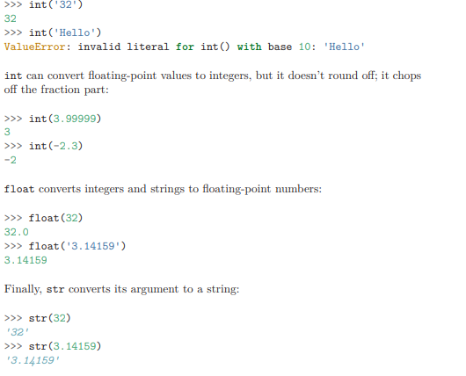

### 4.6 Adding new functions

* Once we define a function, we can reuse the function over and over throughout our program